

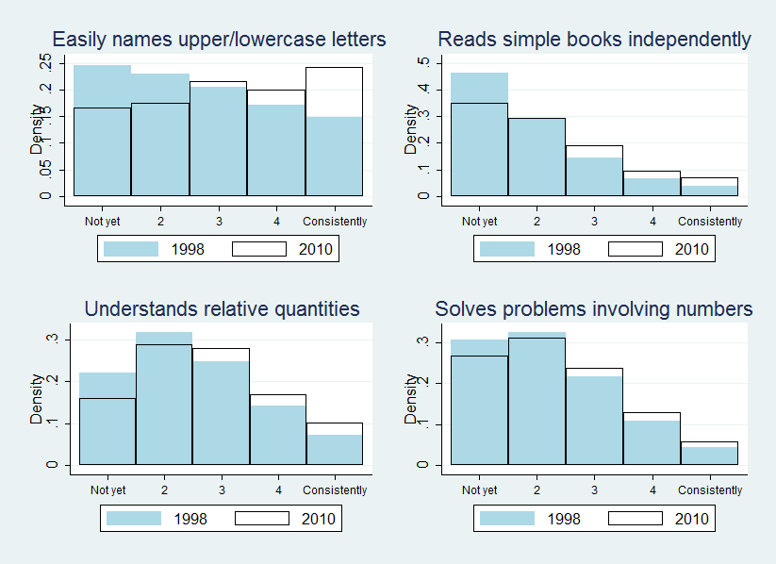**Figure 1. Distribution of selected teacher-reported literacy and math skills**

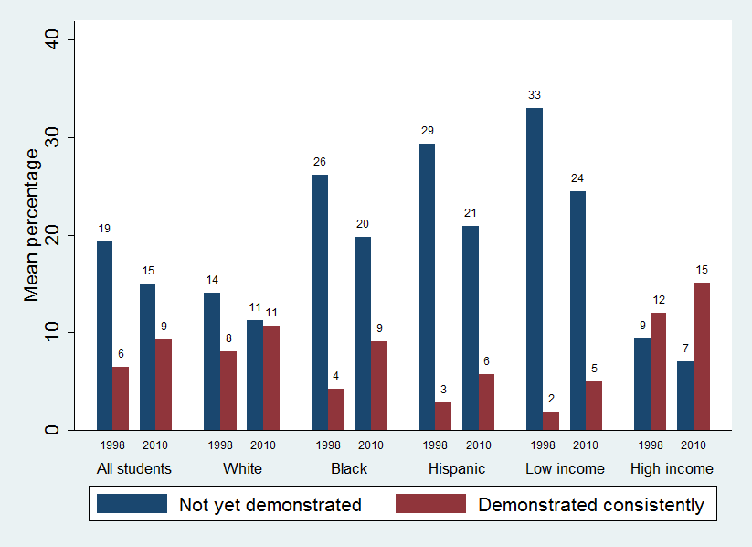**Figure 2. Percentage of math skills that entering kindergarteners had demonstrated**



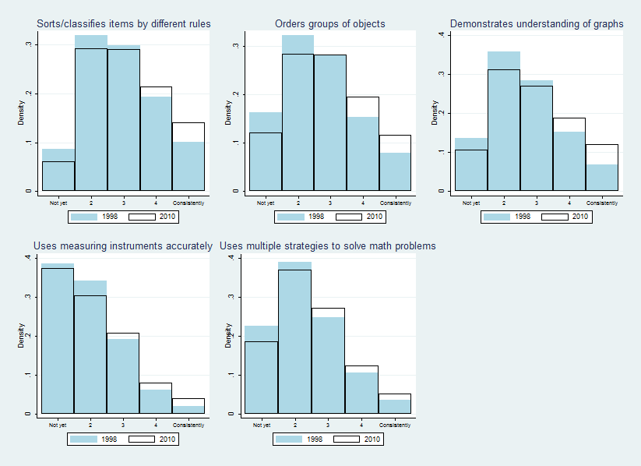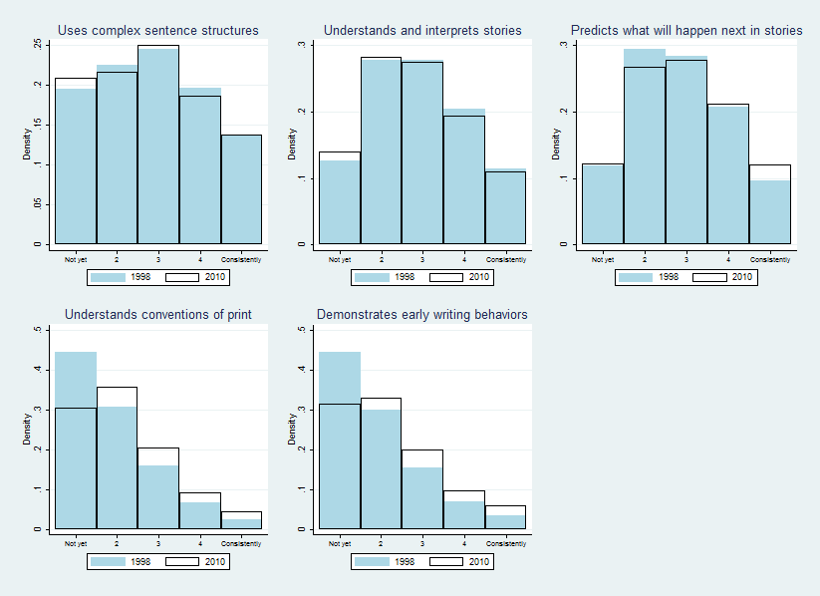**Appendix C. Distribution of additional teacher-reported literacy and math skills** **Appendix D. Percentage of literacy skills that entering kindergarteners had demonstrated**

